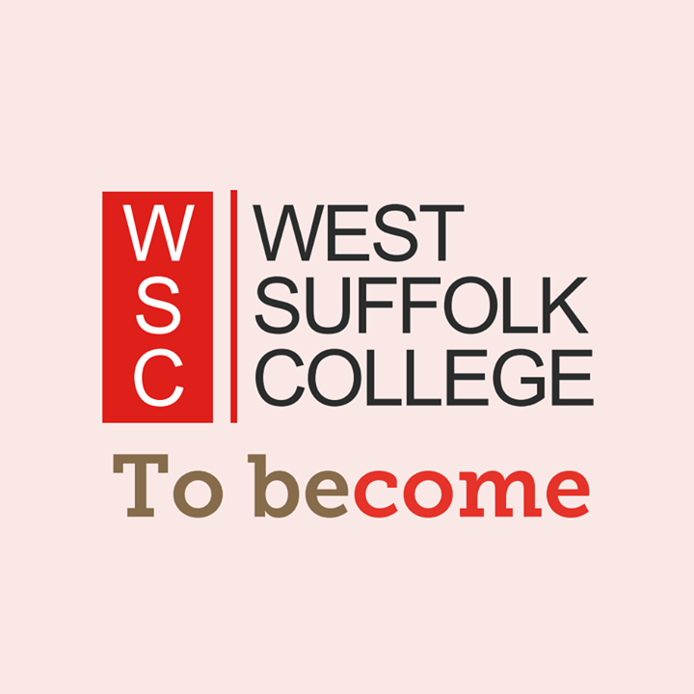
My Transition Passport

My name is
_________________________________________
and I started my Transition Passport on
(Date)____________________________________

My Learning Aims

I would like my Supported Learning Pathway to help me: | Tick if yes
Build my confidence and become more independent as a person.
Express myself and develop my communication skills in a range of settings.
Develop and apply the skills I need for learning, life and work.
Use strategies to help me manage problems or challenges.
Access appropriate educational, community and work-related opportunities.
Recognise ways that I can keep as healthy and well as possible.
Make positive choices and progress towards my learning, life and work goals.

My One Page Profile
My name is/ I’m known as:

Things I’d like you to know about me:
Photo/ drawing:

What people like and admire about me:
Things I can find difficult are:
How I like to communicate:

How I like my feedback:
How I like to be supported:
How I like to learn:

What I like and am good at:
What’s important to me now?

Things I’d like to work towards for the future are:
My Pathway is best for me because:
My VARK Learning Style
Learning Style | Is this me? | I learn best by…
Visual  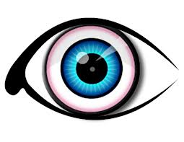 | Yes  Sometimes  No | 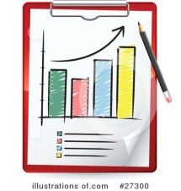  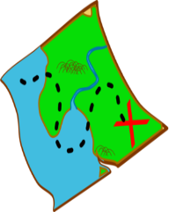  Having pictures/ images  to look at.
Aural  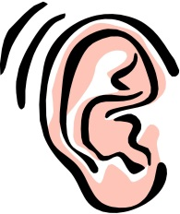 | Yes  Sometimes  No | Listening to people explain and talking through tasks.  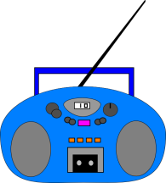  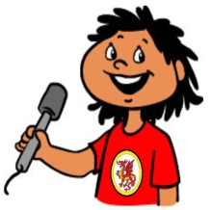  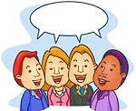
Read/Write | Yes  Sometimes  No | Looking at written words and writing things down.
Kinaesthetic  ‘hands-on’  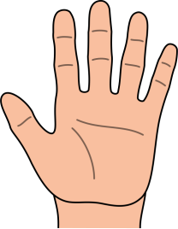 | Yes  Sometimes  No | Doing tasks where I use my hands and move around.
Date completed on:

My Personal Wellbeing Plan
When I’m feeling good… | Things I find hard to deal with…
What helps me calm down/ feel better… | How I might act when it’s difficult…
My EHCP Outcomes – my words and my goals
My Communication  Future  Goals | My Learning
My Wellbeing | My Feelings

My Starting Point
Give yourself a Star Rating of 1 - 5 for each skill/quality below:
1= not good | 2 = ok | 3 = good | 4 = very good | 5 = excellent

My Skills/Qualities | My  Star Rating | I want to improve this
Personal and Social Development
Confidence

Communication

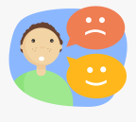
Sharing how I feel

Coping with problems

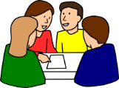
Working with
others

Trying new things

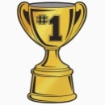
Recognising my
skills/ strengths

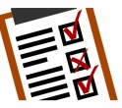
Recognising areas
to improve

Functional Skills
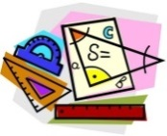
Maths

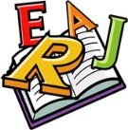
English

Computers (I.T.)

Independent Living Skills
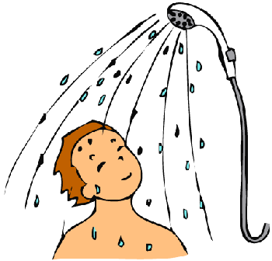
Personal care

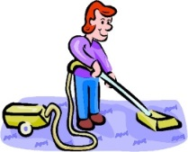
Cleaning/ tidying

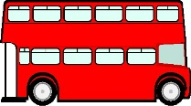
Travel skills

Going into the community

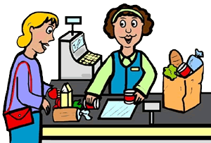
Shopping/
Budgeting

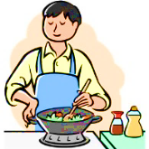
Cooking

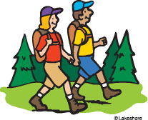
Health and
wellbeing

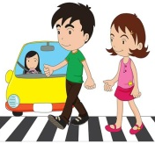
Staying safe

Work-related Skills
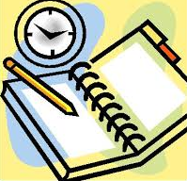
Organisation/ timekeeping

Completing tasks

Taking
responsibility

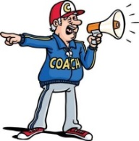
Following
instructions

Working as
a team

Gaining work
experience

Job searching

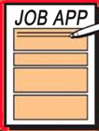
Completing
applications

CV building

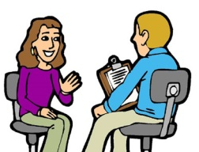
Interview
skills

Date completed:

When to complete my work?

Please complete your Transition Passport either online, by typing into the Word Document, saving this when complete and attaching to an email, or by printing off the document to complete by hand and then taking photographs of each page.

Email your work to paula.buckenham@wsc.ac.uk by Wednesday 19th August.

