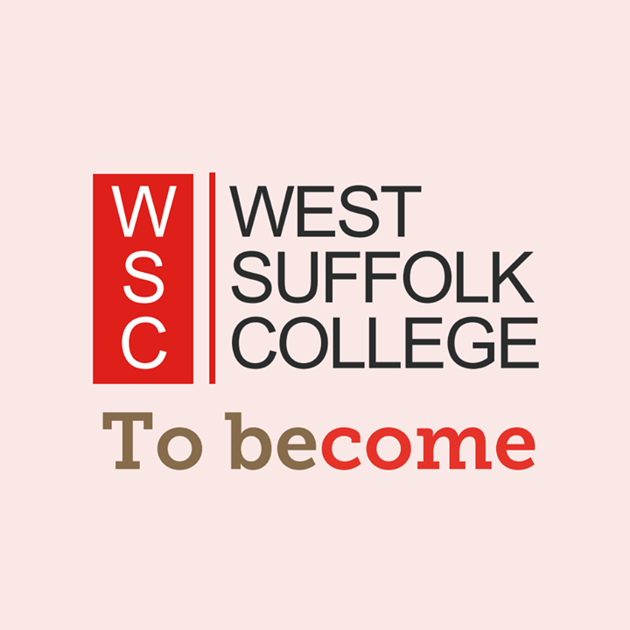
My Transition Passport

Name:

Date of Birth:

Current school/ provider:

Course applied for at college:

Date Transition Passport completed:

My Learning Aims for College

I would like my college course to help me work towards: | Tick  if yes
Build my confidence and become more independent as a person.
Express myself and develop my communication skills in a range of settings.
Develop and apply the skills I need for learning, life and work.
Use strategies to help me manage problems or challenges.
Access appropriate educational, community and work-related opportunities.
Recognise ways that I can keep as healthy and well as possible.
Make positive choices and progress towards learning, life and work goals.

My One Page Profile
My name is/ I’m known as:

Photo/drawing (something important to me): |  | Things I’d like you to know about me:
What people like and admire about me:

How I like to communicate: |  | Things I can find difficult are:
How I like to learn: | How I like to be supported: |  | How I like my feedback:
What’s important to me now? |  | Skills and strengths I have are:
Things I’d like to work on for the future are:

My college course is best for me because…

My VARK Learning Style

Learning Style | Is this me? | I learn best by…
Visual  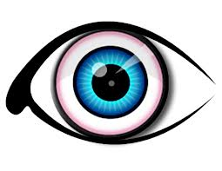 | Yes  Sometimes  No | 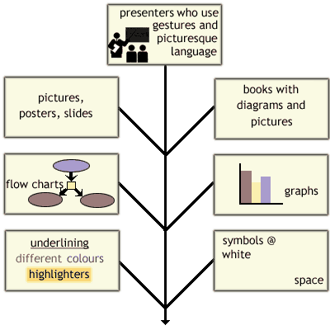
Aural  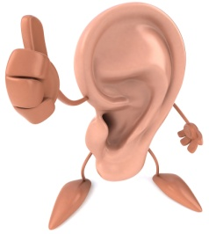 | Yes  Sometimes  No | - Participating in classes, discussions & tutorials.  - Discussing topics & new ideas with others  - Remembering examples, stories & jokes.  - Explaining relevance of headings/pictures in words.  - Leaving space in notes to add to later.
Read/Write  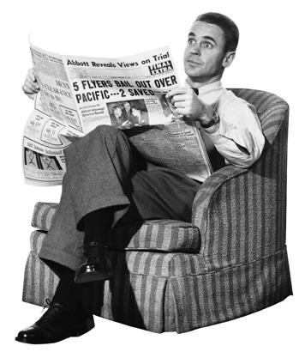 | Yes  Sometimes  No | - Using and seeing headings, sub-headings & lists.  - Using dictionaries, definitions and glossaries.  - Having handouts and textbooks  - Reading up on things & making notes.  - Teachers who use words well & have lots of information in sentences & on sheets.
Kinesthetic  ‘hands-on’  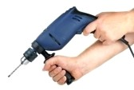 | Yes  Sometimes  No | - Using all your senses: sight, touch, taste, smell, & hearing.  - Demonstrations & experiments which show steps to follow a process.  - Field trips & physical/action activities.  - Teachers who give real-life examples.  - Hands-on approaches: fixing things, practical work, computing.

My Personal Wellbeing Plan
When I’m feeling good, I like to… | Things I find hard to deal with…
What helps me calm down/ feel better? | How I might act when it’s difficult…
EHCP Outcomes – my words and my goals
Communication/ Interaction  Future  Goals | Thinking/ Learning
Health/ Wellbeing | Social/ Emotional

Starting Point - PSD
Give yourself a score between 0 and 3 for each skill/quality below:

0 = not good | 1 = OK | 2 = good | 3 = excellent

Personal and Social Development | Starting point score
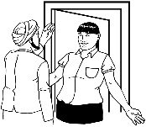
Confidence

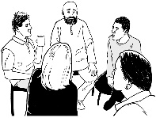
Communication
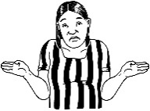
Sharing how I feel
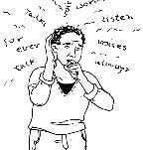
Coping with problems
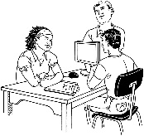
Working with others
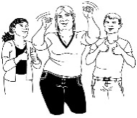
Trying new things
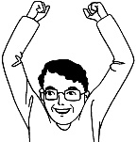
Recognising my skills/ strengths
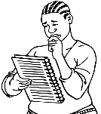
Recognising areas to improve

Starting Point – Maths and English
Give yourself a score between 0 and 3 for each skill/quality below:

0 = not good | 1 = OK | 2 = good | 3 = excellent

Functional Skills | Starting Point score
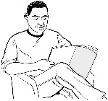
Reading
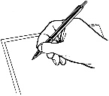
Writing
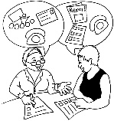
Speaking, Listening and Communication
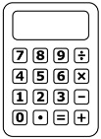
Number
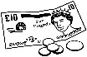
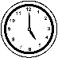
Measure, Shape and Space
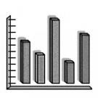
Handling Data
ICT skills
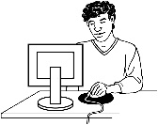

Starting Point – Independent Living
Give yourself a score between 0 and 3 for each skill/quality below:

0 = not good | 1 = OK | 2 = good | 3 = excellent

Independent Living Skills | Starting point score
Daily routine

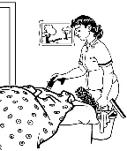
Cleaning/ tidying
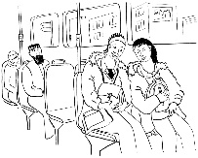
Travel skills
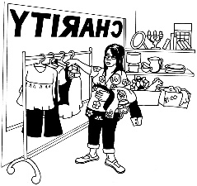
Going into
the community
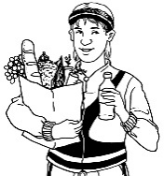
Shopping/
Budgeting
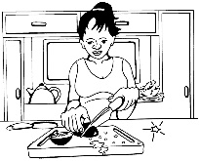
Cooking
Health and
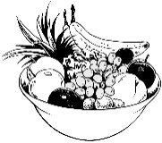
Wellbeing
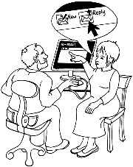
Staying safe

Starting Point – Employability
Give yourself a score between 0 and 3 for each skill/quality below:

0 = not good | 1 = OK | 2 = good | 3 = excellent

Work-related Skills | Starting point score
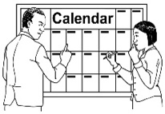
Organisation/
timekeeping
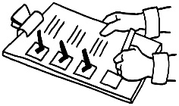
Completing tasks
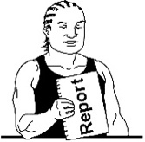
Taking
responsibility
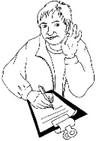
Following
instructions
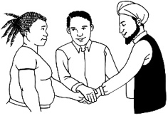
Working as
a team
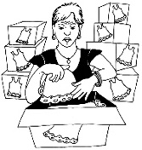
Gaining work
experience
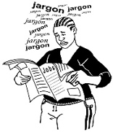
Job searching
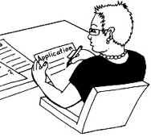
Completing
applications
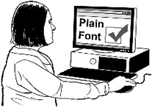
CV building
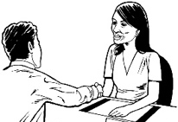
Interview skills

When to complete my work?

Please complete your Transition Passport either online, by typing into the Word Document, saving this when complete and attaching to an email, or by printing off the document to complete by hand and then taking photographs of each page.

Email your work to paula.buckenham@wsc.ac.uk by Wednesday 19th August.

