getting to know you

Pathway To Achieve Team

Inclusive Learning

------------------------

WSC

2020

Liam Purton  Lecturer in Inclusive Learning |  | Addy Jenkins  Lecturer in Inclusive Learning |  | Tom Marsden  Lecturer in Inclusive Learning
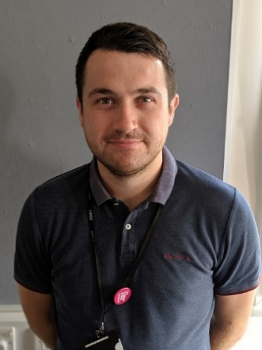 |  | 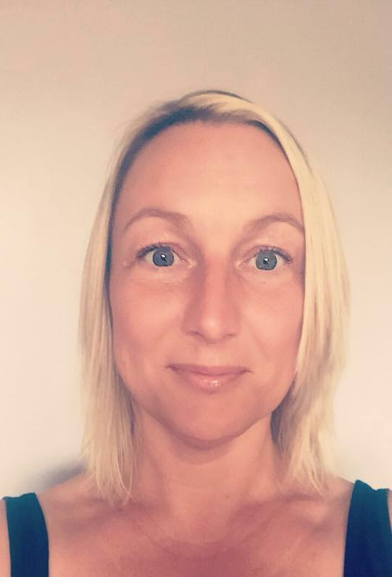
Liam is most likely to enjoy pointless trivia |  | Addy is most likely to have a cuppa in her hands and pinching the biscuits! |  | Tom is most likely to be winding up Liam
Kelly Boyns  PST in Inclusive Learning |  | Jamie Wilks  Lecturer in Inclusive Learning |  | Paula Buckenham  SEN Transition Coordinator/Lecturer
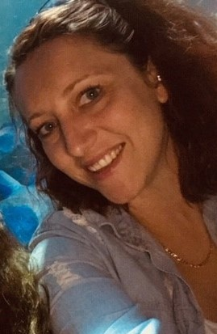 |  |  |  | 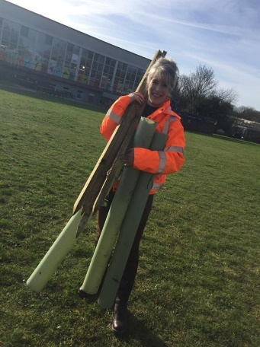
Kelly is Most likely to be kind |  | Jamie is most likely to be the one telling dad jokes! |  | Paula is most likely to bust out bad dance moves during sessions!

Getting to Know you

IN THIS SECTION:

We have added a few worksheets for you to complete to help us get to know your working style and things of interest.
Things that are important to you help us to create activities you find interesting.
Tab 1
Getting to Know You
I would like the Pathway to Achieve course to help me: | Tick  if yes
Build my confidence and become more independent as a person.
Express myself and develop my communication skills in a range of settings.
Develop and apply the skills I need for learning, life and work.
Use strategies to help me manage problems or challenges.
Access appropriate educational, community and work-related opportunities.
Recognise ways that I can keep as healthy and well as possible.
Make positive choices and progress towards learning, life and work goals.

Make your own One Page Profile
My name is/ I’m known as:

Photo/drawing (something important to me): |  | Things I’d like you to know about me:
What people like and admire about me:

How I like to communicate: |  | Things I can find difficult are:
How I like to learn: | How I like to be supported: |  | How I like my feedback:
What’s important to me now? |  | Skills and strengths I have are:
Things I’d like to work on for the future are:

This Pathway is best for me because…

VARK Learning Style

Learning Style | Is this me? | I learn best by…
Visual  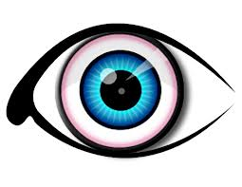 | Yes  Sometimes  No | 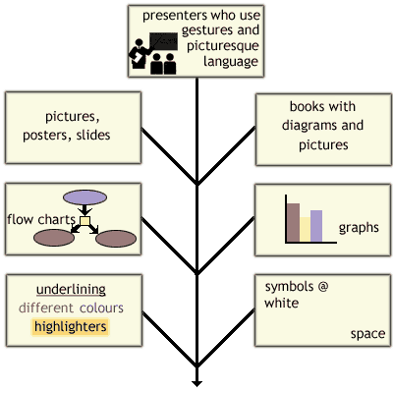
Aural  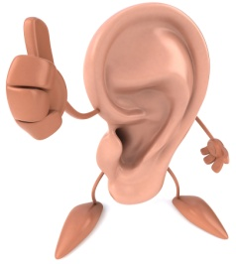 | Yes  Sometimes  No | - Participating in classes, discussions & tutorials.  - Discussing topics & new ideas with others  - Remembering examples, stories & jokes.  - Explaining relevance of headings/pictures in words.  - Leaving space in notes to add to later.
Read/Write  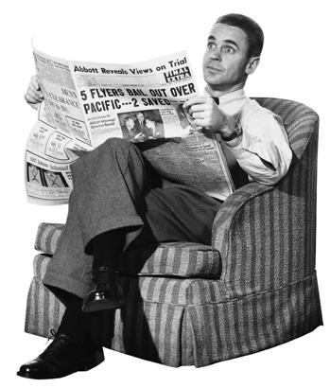 | Yes  Sometimes  No | - Using and seeing headings, sub-headings & lists.  - Using dictionaries, definitions and glossaries.  - Having handouts and textbooks  - Reading up on things & making notes.  - Teachers who use words well & have lots of information in sentences & on sheets.
Kinesthetic  ‘hands-on’  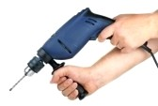 | Yes  Sometimes  No | - Using all your senses: sight, touch, taste, smell, & hearing.  - Demonstrations & experiments which show steps to follow a process.  - Field trips & physical/action activities.  - Teachers who give real-life examples.  - Hands-on approaches: fixing things, practical work, computing.

Personal Wellbeing Plan
When I’m feeling good,  I like to… | Things I find hard to  deal with…
What helps me calm down/ feel better? | How I might act when it’s difficult…

0 = not good | 1 = OK | 2 = good | 3 = excellent
Personal and Social Development | Starting point score
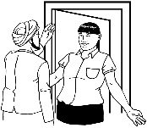
Confidence

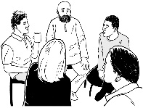
Communication
Sharing how I feel
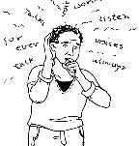
Coping with problems
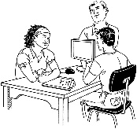
Working with others
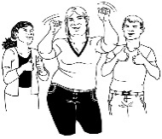
Trying new things
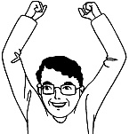
Recognising my skills/ strengths
Starting Points - PSD

Give yourself a score for each skill/quality

Starting Points – Functional Skills

0 = not good | 1 = OK | 2 = good | 3 = excellent

Give yourself a score for each skill

Functional Skills | Starting Point  Score
Reading
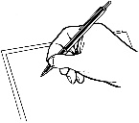
Writing
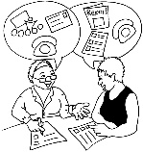
Speaking, Listening and Communication
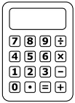
Number
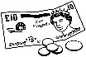
Measure, Shape and Space
Handling Data
ICT skills

Starting Points - Employability
Give yourself a score for each skill/quality
0 = not good | 1 = OK | 2 = good | 3 = excellent

Work-related Skills | Starting point Score
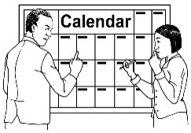
Organisation/ timekeeping
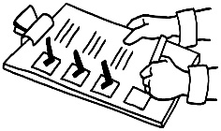
Completing tasks and applications
Taking
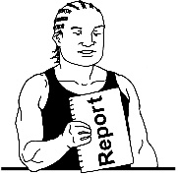
responsibility
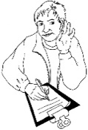
Following
instructions
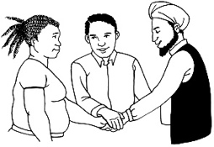
Working as
a team
Gaining work
experience
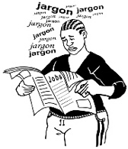
Job searching /CV building
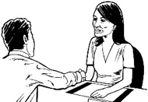
Interview skills

Biography

IN THIS SECTION:

- A couple of fun tasks to see the amusing side of you
Tab 2
Seven Word Biography
Write your life story in seven words exactly. Think carefully and use words that will sum up your life experiences. Examples:
-fostered, moved school, boyfriend, playing football, happier
-new brother, mum ill, dog, banger racing

Two Truths and a Lie
Tell us 3 facts about yourself. 2 should be true, 1 should be a lie. List them in any order so we don't know which is which. Remember to make the lie believable and the truths interesting, as this will make the lie harder to guess! Examples:
-I play the guitar, I was born in Wales, I once met Simon Cowell
-My cousin plays for Arsenal, I love marmite, I've got a tarantula

What's in a name?
For each letter of your first name, come up with a
describing word which applies to you.
You can cheat a bit if you get stuck!
For example (Jamie):
Joker
Adaptable
Mentor
Imaginative
Easily led

Past, Present & Future

IN THIS SECTION:

- Let’s get creative

Tab 3

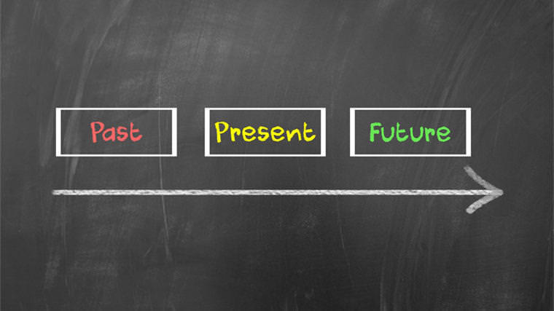
Past, Present, Future

Your task is to draw, brainstorm, write or use any other creative form you wish to design a poster about your past, present and future. This can be as detailed as you like. You could do your past as your experience at school, present as what you do now and future as where you want to be. Your past could be an activity you enjoyed doing before, the present an activity you enjoy doing now and your future could be something you want to become good at…

Be as creative as you can. We want to get to know you a bit without having to interview you! We have divided the other side of the page into 3 sections to represents past, present future. You don’t have to use this if you have your own ideas though.

