



**My favourite…**

Movie: ………………………………………

TV Show: ………………………………

Videogame: ……………………………

**Name: ………………………………….**

**I.D**

**Draw your favourite meal**

**………………………**

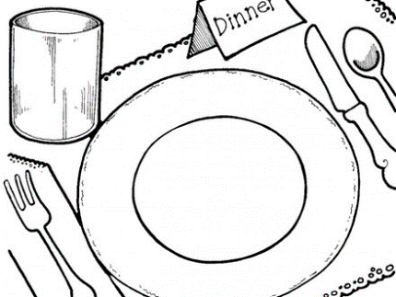

**All About Me!**

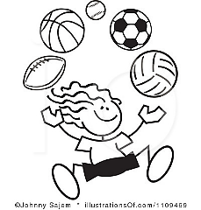

**My**

**favourite sports**

**……………………**

**My favourite book**

**………………………**

**My favourite music**

**………………………**

**My favourite animal**

**………………………**

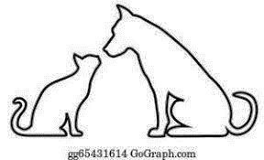

**Please add colour to this page if you like.**

