Unit 5 – Anatomy and Physiology

The skeletal system

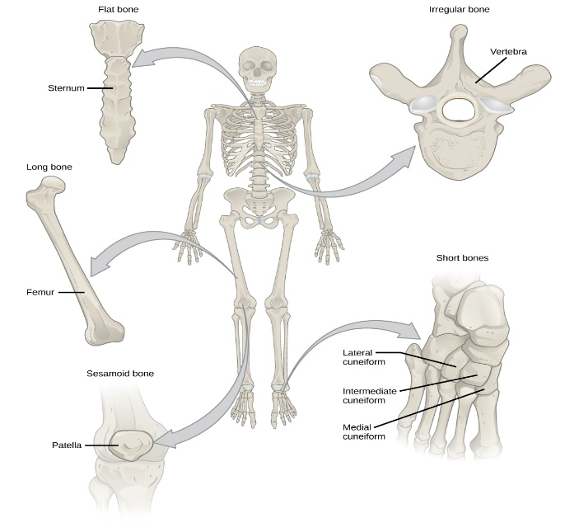
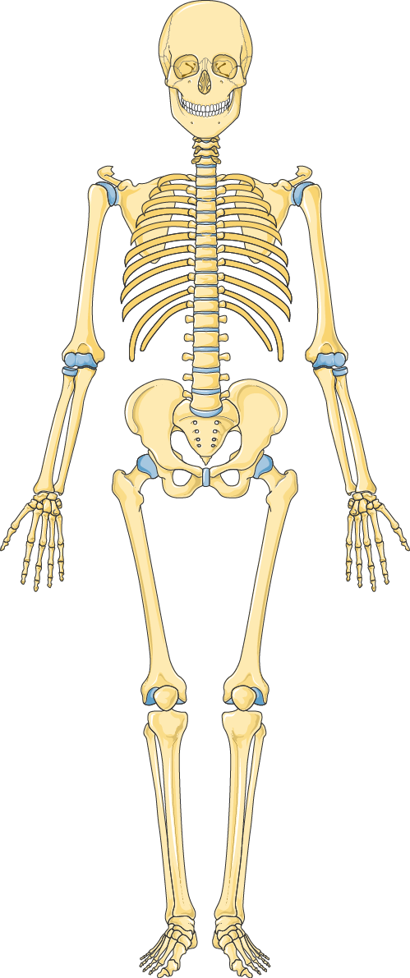

- Label the following bones of the skeleton
- cranium
- clavicle
- ribs
- sternum
- humerus
- radius
- ulna
- scapula
- ilium
- pubis
- ischium
- carpals
- metacarpals
- phalanges
- femur
- patella
- tibia
- fibula
- tarsals
- metatarsals
- Vertebral column

2 )
a) Highlight the axial and appendicular skeleton on the diagram.
b) Describe the functions of the axial and appendicular skeleton
c) Provide examples of bones from the axial and appendicular skeleton
Axial skeleton

Appendicular skeleton

3) Label the vertebral column and describe the main function and characteristics of each section

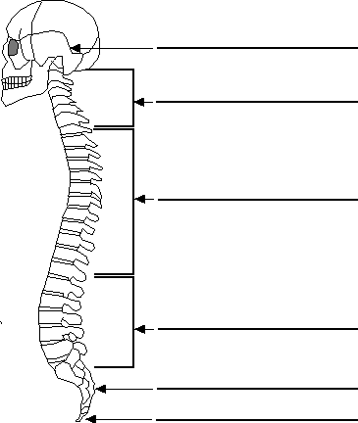

Section | Function and characteristics

