L3 Working in Sport and Fitness Industry

Unit 1: Exercise, Health and Lifestyle

Handbook

Learner name: …………………………………….

Learning outcome

The learner will:

Produce and use a questionnaire to assess the lifestyle of a suitable individual.

The learner must:

- produce a lifestyle questionnaire.
- use the questionnaire with a suitable individual.

The following is an example questionnaire to assess the lifestyle of a suitable individual and is aimed more as a guide. This is not to be used as learner evidence for LO2 as this requires the learner to produce their own lifestyle questionnaire.

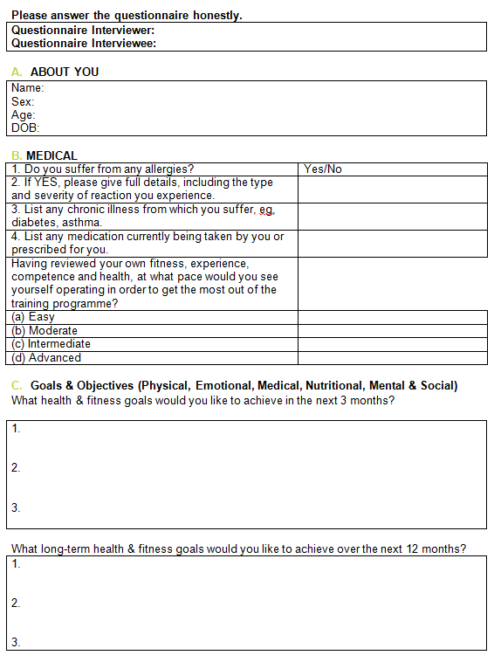

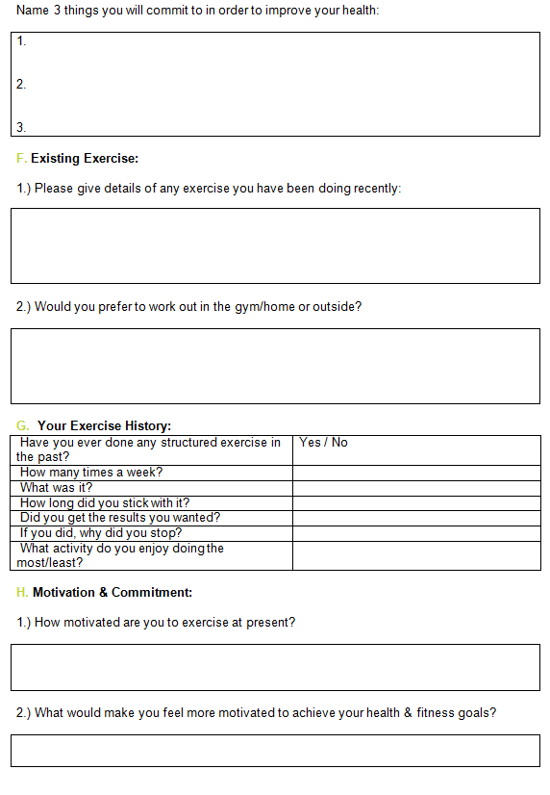
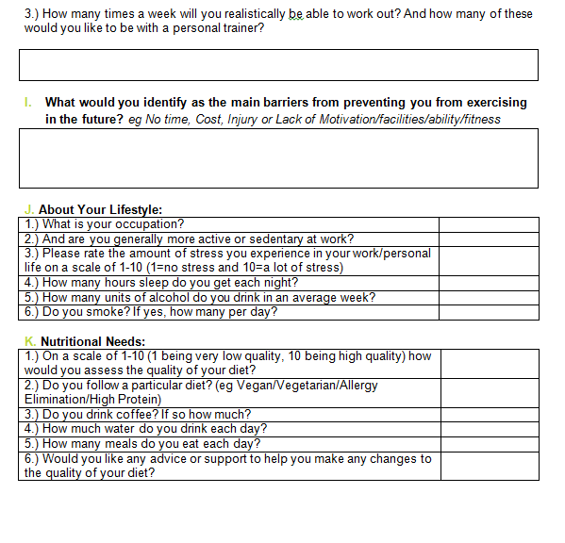

Learning outcome

The learner will:

Analyse the lifestyle of the selected individual based on the information collected in the lifestyle questionnaire.

The learner must:

- Provide lifestyle improvement strategies

Lifestyle Improvement Strategies

These changes could include:

- Ways to increase physical activity levels by walking, stair climbing, cycling

- Reducing the intake of alcohol by seeking alternatives, attending counselling and therapy, detoxification, self-help groups, alternative treatment and therapies

- Reducing or stopping smoking by acupuncture, NHS smoking helpline, NHS stop-smoking services, nicotine replacement therapy

- Helping to reduce stress by developing stress management techniques like assertiveness, goal setting, time management, physical activity, positive self-talk, relaxation, breathing

- Producing a diet plan that supports better timing of food intake, eating more or less of certain foods, food preparation.

Using the questionnaire from LO2, analyse the lifestyle of the selected individual and provide lifestyle improvement strategies in the below table. You must include;

- Improvement strategies
- Relate to current health recommendations and guidelines

Lifestyle factor | Improvement Strategy
Exercise
Alcohol
Smoking
Stress
Drugs
Diet
Mental Wellbeing
Social Wellbeing

In this section you need to do the following;

- Prioritise your recommended lifestyle improvement strategies using the table below (1 being the highest priority and 10 being the least priority)
- Clearly explain the order of prioritisation for each improvement strategy recommended

Lifestyle factor? | Explanation of the priority of the recommended Improvement Strategy
1.
2.
3.
4.
5.
6.
7.
8.
9.
10.
Learning outcome

The learner will:

Produce a health-related physical activity plan for the selected individual

The learner must:

- Produce a health-related physical activity plan for the selected individual based on the information gathered in LO3

Principles of Training

‘SPORV’ Principles – Specific, Progression, Overload, Reversibility, Variation
Specific
Progression
Overload
Reversibility
Variation

‘FITT’ Principles – Frequency, Intensity, Time, Type
Frequency
Intensity:

Rating of Perceived Exertion (RPE)
Time
Type

Periodisation
Microcycle
Mesocycle
Macrocycle

Health Training Programme Targets

Aim of personal activity programme. Use SMART targets;

Specific
Measurable
Achievable
Realistic
Time
SMART Targets
Short Term
Medium Term
Long Term

Health-related physical activity plan

Learners must plan a 6-week health-related physical activity plan for the individual, taking into account the information collected in the lifestyle questionnaire. For example their personal goals, lifestyle, medical history, physical activity history, attitudes and motivation.

The plan must:

- be tailored to the individual’s needs
- include appropriate activities for the individual
- include SMART (short, medium and long term) objectives
- include the principles of training (overload, specificity, progression, individual differences, variation, and reversibility).
- Include the FITT (frequency, intensity, time and type) principles.

The plan could include practical information for the individual in regards to exercise intensity eg

- rate of perceived exertion (RPE)
- maximum heart rate
- maximum heart rate reserve

The learner could provide rationale for the choices and recommendations they have made

Health-related physical activity plan

Week 1
Day | Rest Day | Muscular Endurance  Exercises | Muscular Strength Exercises | Lifestyle Strategies | Targets (Link to short, medium or long term)
Monday:

Tuesday:

Wednesday:

Thursday:

Friday:

Saturday:

Sunday:

Health-related physical activity plan

Week 2

Day | Rest Day | Muscular Endurance  Exercises | Muscular Strength Exercises | Lifestyle Strategies | Targets (Link to short, medium or long term)
Monday:

Tuesday:

Wednesday:

Thursday:

Friday:

Saturday:

Sunday:

Health-related physical activity plan

Week 3
Day | Rest Day | Muscular Endurance  Exercises | Muscular Strength Exercises | Lifestyle Strategies | Targets (Link to short, medium or long term)
Monday:

Tuesday:

Wednesday:

Thursday:

Friday:

Saturday:

Sunday:

Health-related physical activity plan

Week 4
Day | Rest Day | Muscular Endurance  Exercises | Muscular Strength Exercises | Lifestyle Strategies | Targets (Link to short, medium or long term)
Monday:

Tuesday:

Wednesday:

Thursday:

Friday:

Saturday:

Sunday:

Health-related physical activity plan

Week 5
Day | Rest Day | Muscular Endurance  Exercises | Muscular Strength Exercises | Lifestyle Strategies | Targets (Link to short, medium or long term)
Monday:

Tuesday:

Wednesday:

Thursday:

Friday:

Saturday:

Sunday:

Health-related physical activity plan

Week 6
Day | Rest Day | Muscular Endurance  Exercises | Muscular Strength Exercises | Lifestyle Strategies | Targets (Link to short, medium or long term)
Monday:

Tuesday:

Wednesday:

Thursday:

Friday:

Saturday:

Sunday:

Health-related physical activity plan

Weeks | Rationale for choices / recommendations: | Targets (Link to short, medium or long term)
Week 1

Week 2
Week 3
Week 4
Week 5
Week 6

Reference Page

