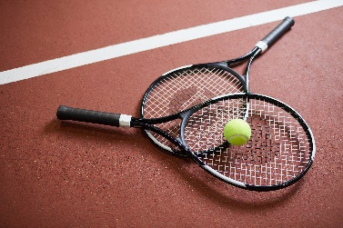
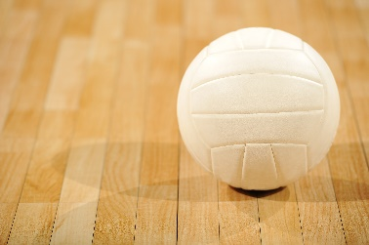
Practical Sport
Summer workbook

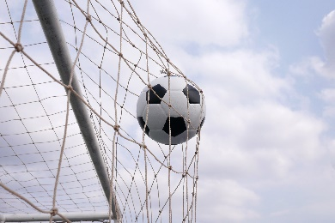
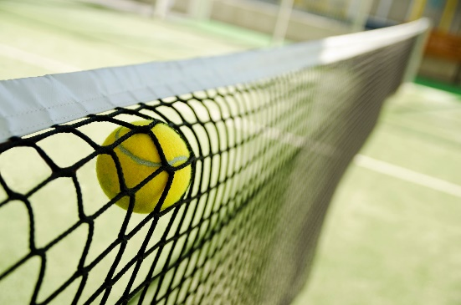

This work booklet is designed to support and prepare you for your practical sports unit. The tasks are focused on the rules, regulations, scoring systems and concepts of fair play in a chosen sport.

Please complete all tasks in the booklet. Please research topics to support your answers.

Please complete this work booklet by August 7th 2022. Please email your completed booklet to tommi.charlish@wsc.ac.uk

I look forward to welcoming you to West Suffolk College, enjoy your summer!

Name: __________________________

Task 1: Selecting one sport.

My chosen sport is (e.g. Football) ……………………………...
Insert here some pictures and examples of your chosen sport.

Task 2 : NGBS
National governing bodies
A national governing body is responsible for managing every aspect of their specific sport, from managing a network of clubs, coaches and volunteers that make sport happen, to breaking down barriers to participation at grassroots level, to supporting elite athletes and setting out the rules, regulations and scoring systems.
Examples of national governing bodies include The Football Association, England Netball for The Lawn Tennis Association.
Describe the roles of National Governing Bodies in your sport
My chosen sport is (e.g. Football) ……………………………...

Who is the National governing body for your chosen sport:
e.g The Football Association for Football or the Lawn Tennis Association for Tennis

Describe the role of the national governing body for your chosen sport. Include a description, evidence and examples:

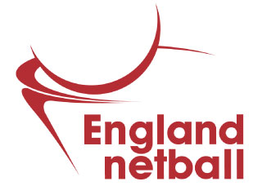
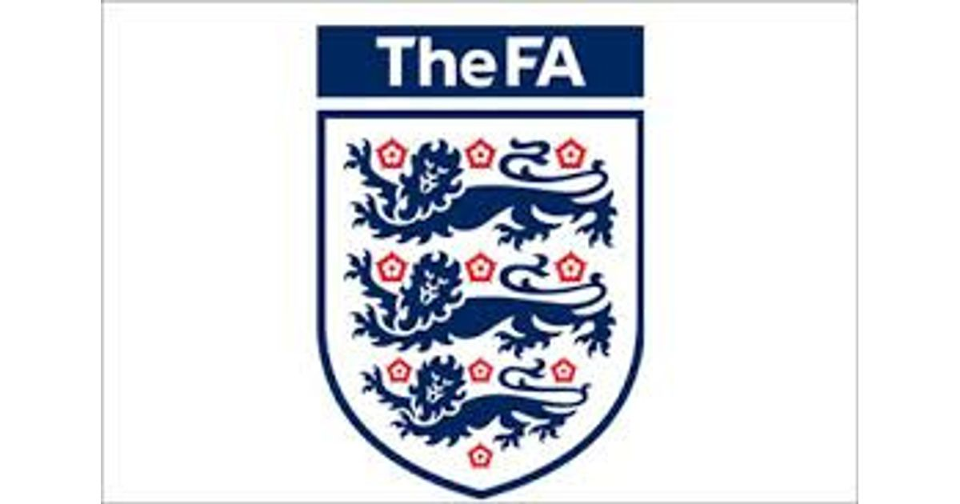

Task 3: Roles and Responsibilities
Roles and responsibilities of officials in your sport
All sports have one or more officials who are responsible for ensuring that the competition, game or match is played safely, fairly and according to the rules and regulations, and that the scoring systems are correctly applied. They will also take disciplinary action against a player or participant who breaks the rules. Officials are given different names depending on their specific role and their sport. Examples of different types of officiating roles include official, umpire, referee, judge, score keeper, time keeper, table officials, referees assistant, 4th official.
The types of responsibilities could include appearance, equipment, fitness, qualifications, interpretation and application of rules, control of players, accountability to spectators, health and safety (equipment, facilities, players), fair play, use of technology, effective communication (voice, whistle, signals)
Identify the roles and responsibilities of the sports officials in your sport.
My chosen sport is (e.g. Football) ……………………………...

Example: Referee

Roles and responsibilities
1 Making decisions in accordance to the rules

2

3

4

5

6

7

8

9

10

Identify a different role and their responsibilities in your chosen sport
Role: e.g Referees assistant

Roles and responsibilities
1

2

3

4

5

6

7

8

9

10

Task 4: Role models
Identify a positive role model in your sport. Identify their key strengths and explain why you think they are a positive role model.
(e.g. Dedication, good communication skills, provides support to charities, good leader)

My role model is :

Key strengths and positive features :

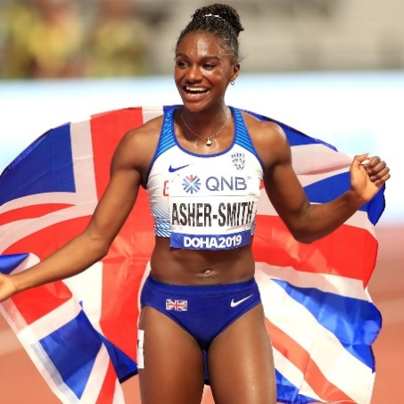
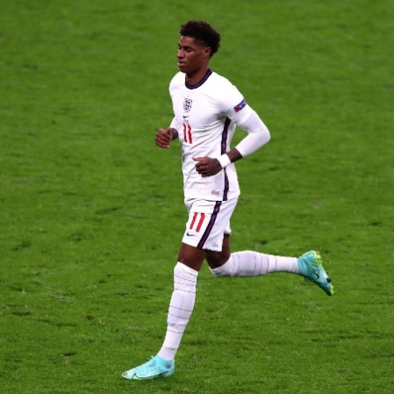

Task 5- Technology in sport
Technology in sport
We use technology in every aspect of our lives to make things easier and sport is no exception. There are now a number of technological innovations that help officials make decisions during matches, games and competitions. Yet not everyone welcomes the introduction of technology. Examples include hawk eye, wireless communication between officials or photo finish cameras.
Positive aspects of using technology in your chosen sport for the officials | Negative aspects of using technology in your chosen sport for the officials
Example: Technology such as Hawk eye, allows for referees to see aspects of the game that the naked eye could not see | Example: Technology can disrupt the flow of the game.
Describe the positive and negative aspects of using technology in your chosen sport.

Task 6- Rules
Identify the rules in your chosen sport
Rules (or laws) are regulated by the national or international governing body for the sport. For example, FIFA (Fédération International de Football Association) laws of football, IRB (International Rugby Board) laws of rugby, BWF (Badminton World Federation) rules of badminton, IOF (International Orienteering Federation) rules of orienteering.
Identity below the rules for your chosen sport with a clear explanation for each.

Rule/law | Explanation
e.g. Offside | e.g. A goal is scored in Football however, the player who scored the goal was in an offside position when they received the ball

Well done! I look forward to receiving this work. Please email this to
Tommi.charlish@wsc.ac.uk

Over the summer, you might wish to watch some interesting sports documentaries such as :

- All or Nothing - Amazon Prime
- CrossFit- Redeemed and the dominant - Amazon Prime
- CrossFit- Fittest in Dubai - Amazon Prime
- Andy Murray Resurfacing - Amazon Prime
- Cristiano Ronaldo: Impossible to ignore - BBC iPlayer

