Unit 1
Anatomy and physiology for exercise
(T/617/4001)
Overview
The unit covers the knowledge and understanding that an instructor needs to plan safe and effective group cycling sessions.
This booklet allows opportunities to provide evidence for assessment criteria 1.1 to 9.5. To support your evidence, the following websites may support you with some important information to complete the tasks:
- www.acsm.org
- www.fitnessindustryeducation.com
- www.bases.org.uk
Supporting evidence
Ensure that all the evidence is available for viewing by the internal and external quality assurer.

Task 3: Using the images below, identify and locate the anterior and posterior skeletal muscles.
(5.3)
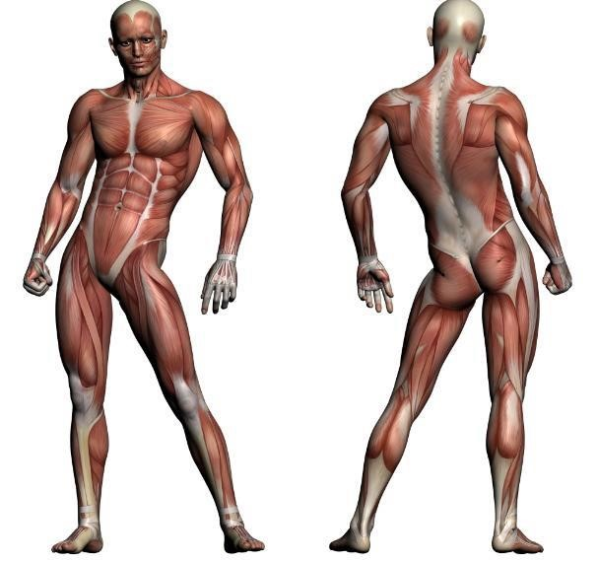
(
Muscles located within this
area under overlying
muscles)

Task 4: Describe the structure and function of the pelvic floor muscles. (5.4)

Muscle action Muscle action type and description | Muscle action Muscle action type and description
Movement
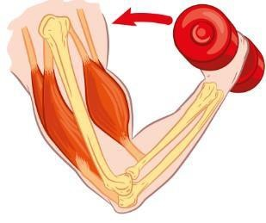
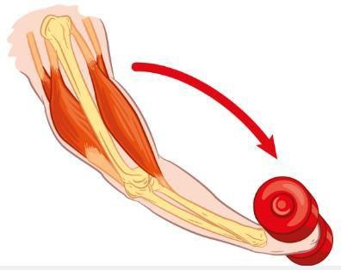
Movement
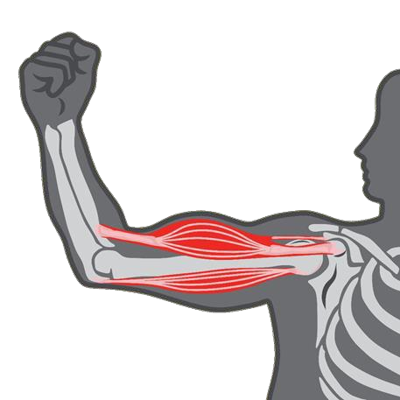
No m
ovement

Muscle fibre | Description of characteristics
Type 1
Type 2

